app.component.html
<!--The content below is only a placeholder and can be replaced.-->
<div style="text-align:center">
<h1 style="text-align: left ">
{{ title }}!
</h1>

</div>

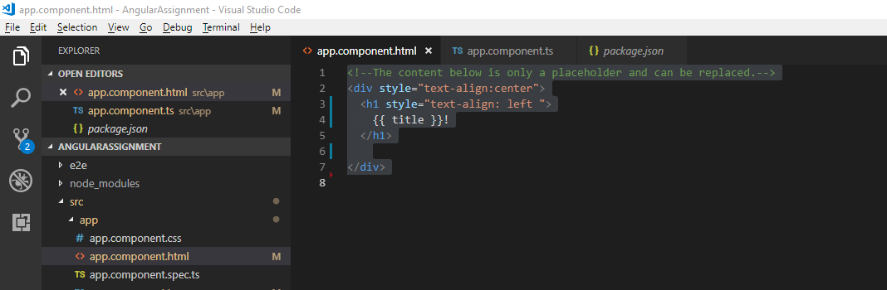
app.component.ts
import { Component } from '@angular/core';

@Component({
selector: 'app-root',
templateUrl: './app.component.html',
styleUrls: ['./app.component.css']
})
export class AppComponent {
title = 'app works' ;
}

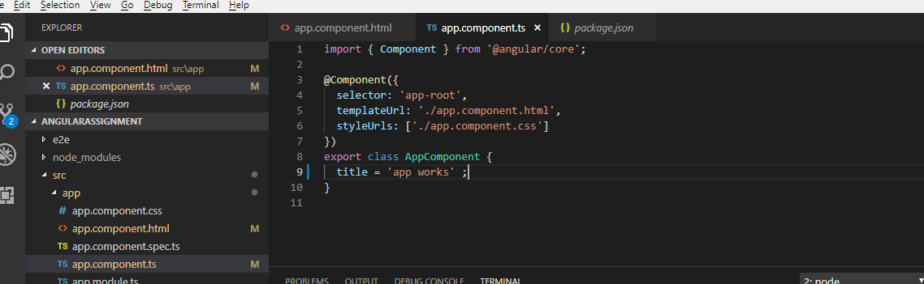
Output:

app.component.ts

import { Component } from '@angular/core';

@Component({
selector: 'app-root',
templateUrl: './app.component.html',
styleUrls: ['./app.component.css']
})
export class AppComponent {
title = 'My Angular 2 app works' ;
}



